Cylon Eyes
www.ipswich-robotics.co.uk

Parts List
- PIC 16F627
- Resistor
- 10 Bar LED
- Vero board 10 x Y holes
- Assorted wire

Tools
- Soldering Iron (and solder)
- Wire cutter
- PIC programmer

Circuit

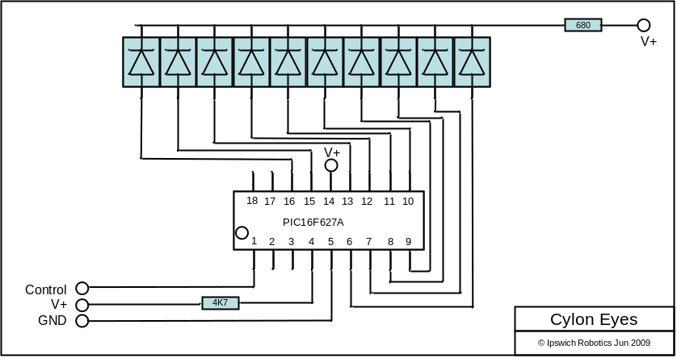

Assembly

Basic steps are:

- Build circuit
- Dismantle Robobuilder head – remove current board
- Solder on to socket ground, v+, and control wire

Circuit layout

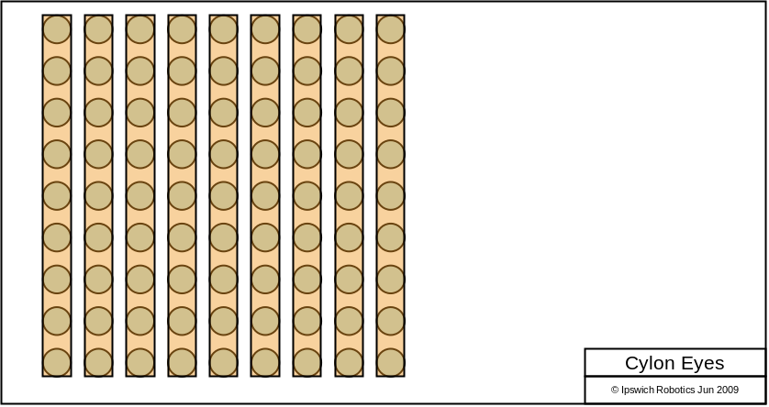

Software

Compile: sdcc --debug -mpic14 -p16f627 ceyes.c
This will create a HEX file that you can the transfer to PIC using a programmer.

How it works

A 10 bit scan. Both numbers are output to ports A & B followed by a delay. The sequence then repeats with the next number in the list until the end is reached, at which point the sequence reverses and the numbers are played back until the start of the sequence is reached. Simple ! You can change the pattern by editing the numbers. An Excel spreadsheet is used to convert the pattern required into decimal numbers.

 |  |  |  |  |  |  |  |  |  |  | Port A | Port B
1 | 1 | 1 | 1 | 1 | 1 | 1 | 1 | 1 | 1 |  | 3 | 255
1 | 0 | 0 | 0 | 0 | 0 | 0 | 0 | 0 | 0 |  | 2 | 0
1 | 1 | 0 | 0 | 0 | 0 | 0 | 0 | 0 | 0 |  | 3 | 0
0 | 1 | 1 | 0 | 0 | 0 | 0 | 0 | 0 | 0 |  | 1 | 128
0 | 0 | 1 | 1 | 0 | 0 | 0 | 0 | 0 | 0 |  | 0 | 192
0 | 0 | 0 | 1 | 1 | 1 | 0 | 0 | 0 | 0 |  | 0 | 112
0 | 0 | 0 | 0 | 1 | 1 | 1 | 0 | 0 | 0 |  | 0 | 56
0 | 0 | 0 | 0 | 0 | 0 | 1 | 1 | 0 | 0 |  | 0 | 12
0 | 0 | 0 | 0 | 0 | 0 | 0 | 1 | 1 | 0 |  | 0 | 6
0 | 0 | 0 | 0 | 0 | 0 | 0 | 0 | 1 | 1 |  | 0 | 3
0 | 0 | 0 | 0 | 0 | 0 | 0 | 0 | 0 | 1 |  | 0 | 1

